**White Themed Screenshots:**

Testing with some context from the SQuAD validation dataset

**Overall Observations on validation dataset:**

* For our validation dataset, it has almost predicted all the answers correctly, except one or two.
* There were few answer misses for one or two.



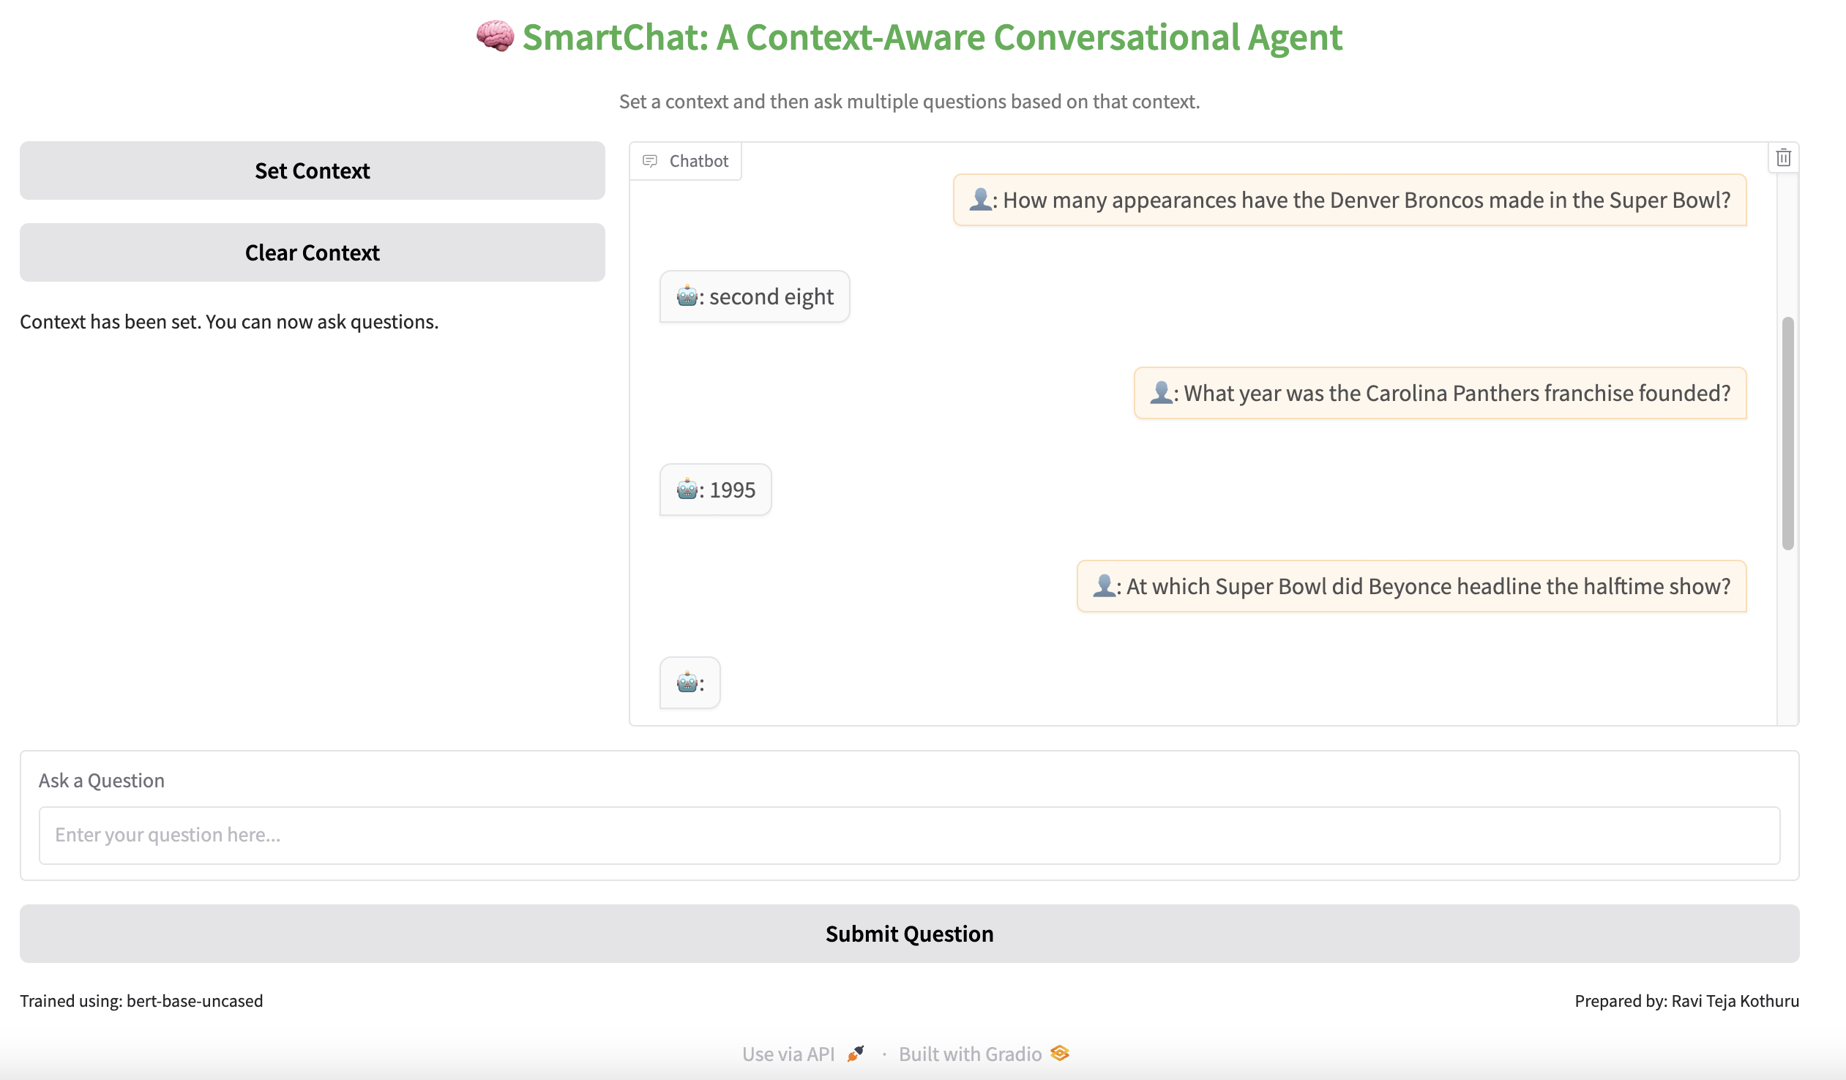

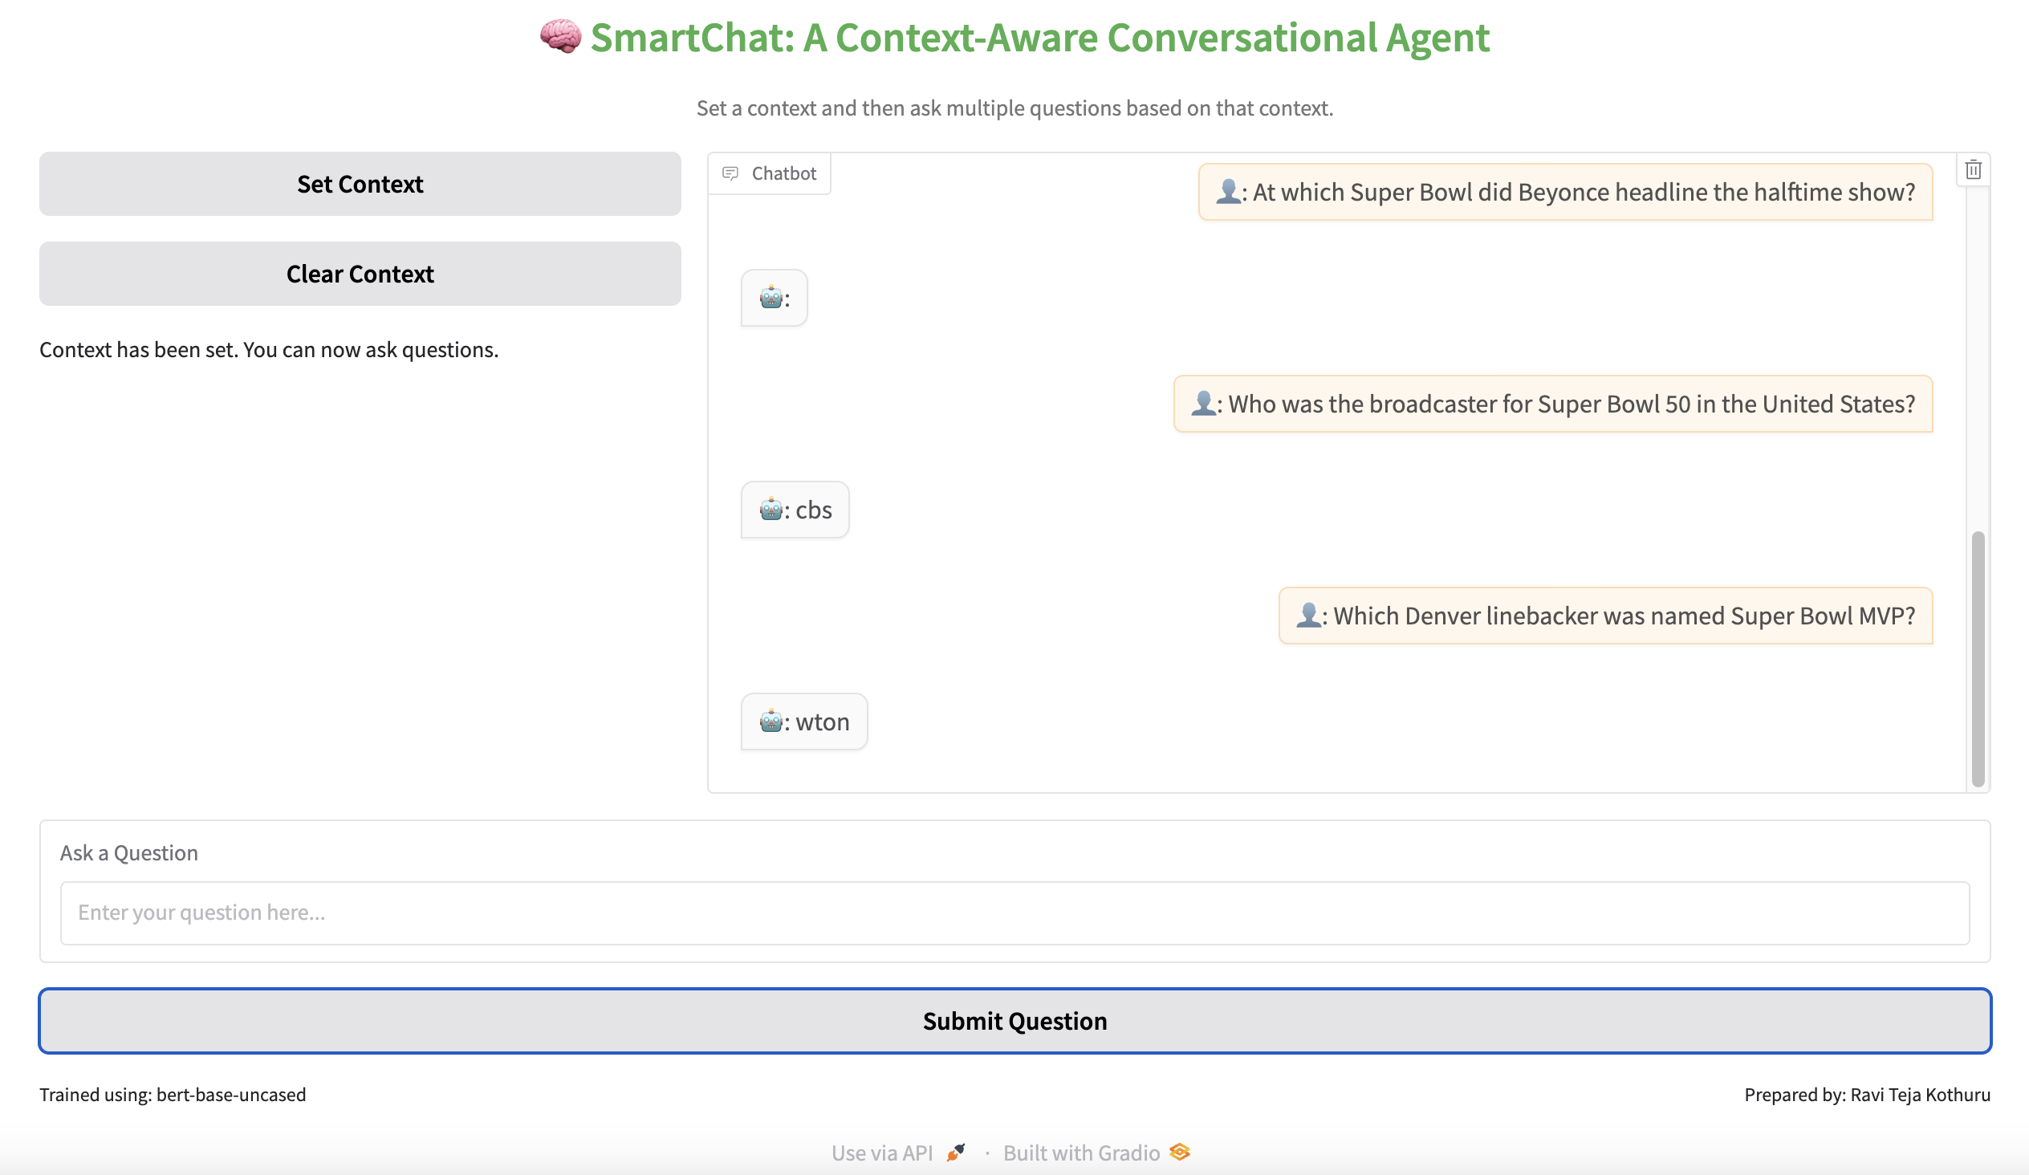

Testing with random context from the internet.

Context – 1: Based on Robotics (with follow-up questions)

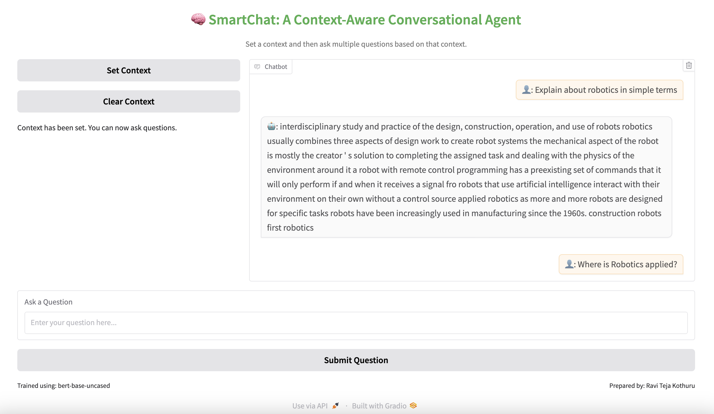



Context – 2: Based on Music (with follow-up questions)

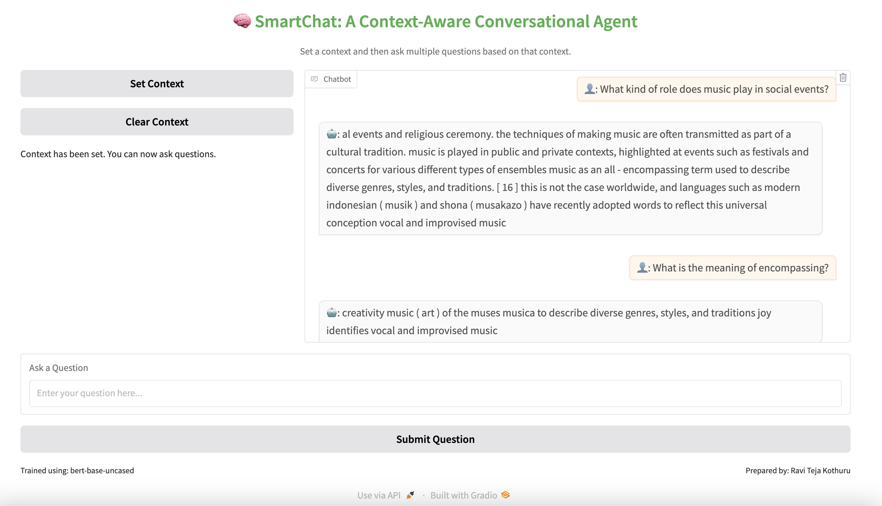

Context-3: Based on ISRO

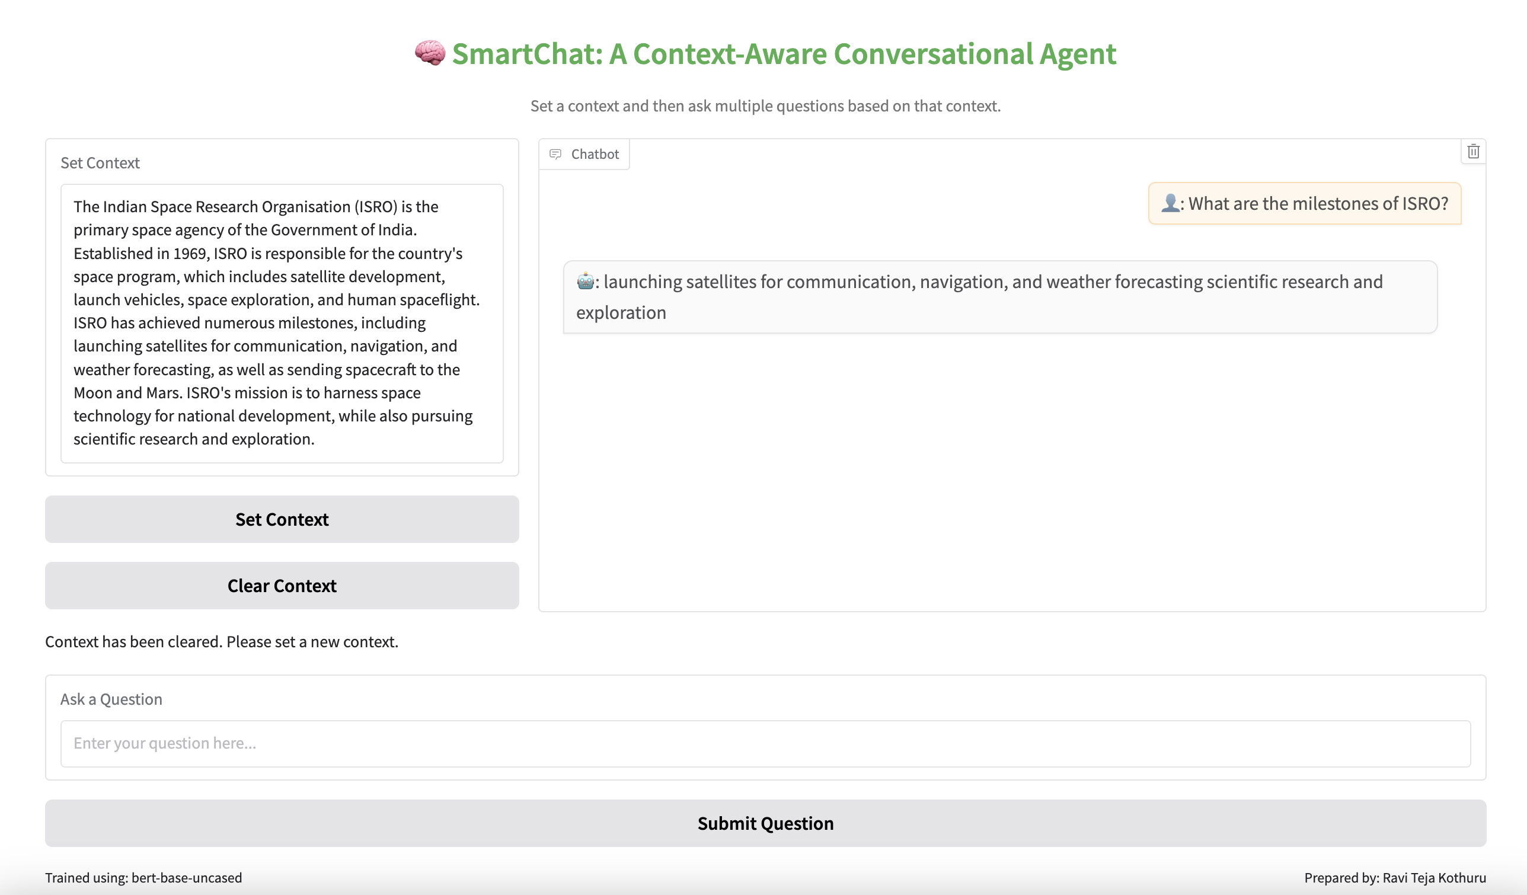

**Overall Observations on contexts taken from internet:**

* It has understood the context very well.
* It has explained the answers to our questions in detail.

**Common error scenario:**

After the context is cleared, you pasted the context but did not set. And if you try to ask a question, then it will throw a message like below.

